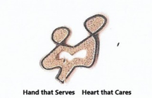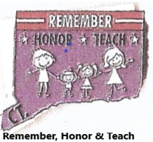

VFW Auxiliary, Department of Connecticut
“Hands that Serve, Hearts that Care,” “Remember, Honor, Teach.”
Auxiliary Outreach Program Flyer #9 & #10
April/May 2023
THANK YOU FOR YOUR PARTICIPATION IN THIS PROGRAM

Thank you to everyone that participated in this program and sent in a report. It’s amazing the volunteering that the auxiliaries in our department did within their communities. I can’t thank you enough. While the program often seems confusing, the auxiliaries figured it out and stepped up to plate when it came to working with organizations and towns across this state.
WHAT happens now? Continue to work this program until the 2023/2024 department chairman take over. This will be done after our Department Convention in June. Work this program as an auxiliary, keep track of what your members are doing, and these activities will be added to the October 2023 program reports that will be due to the new chairman.
According to the National Ambassador for the 2023/2024 program year, NOTHING is changing, therefore if you have members who help out in areas like Soup Kitchens, Thrift Shops, Senior Centers, Blood Drives etc. just continue to keep track of their time.
IT’S IMPORTANT TO REMEMBER THAT THE PROGRAMS DON’T STOP WHEN LOCAL AUXILIARY ELECTIONS TAKE PLACE. NEW OFFICERS & CHAIRMAN TAKE OVER AFTER OUR JUNE CONVENTION, THE AUXILIARY WORKING NEVER STOPS.
Grace Kelly-Chairman

