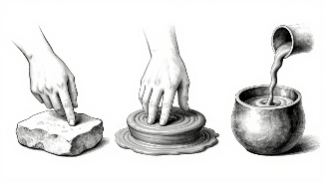
Young American Patriotic Art Contest
&
3 -Dimensional Patriotic Art Contest
(be sure to take a picture of your 3-Dimensional Artwork to include with it)
Open to Grades 9-12
Deadline March 31, 2026
Information at vfwauxiliary.org
Application forms

How have you Promoted these programs?

Were you able to get information into your local High Schools?
Libraries – Town Halls – Park & Recreation Centers – Churches
Local Papers – Social Media
And check out our new QR code 

Connecticut Auxiliary serving Veterans for over 100 years!

