Department of Connecticut VFW Auxiliary
Connecticut Auxiliary serving Veterans for over 100 years
Legislation Flyer #8 January 2026

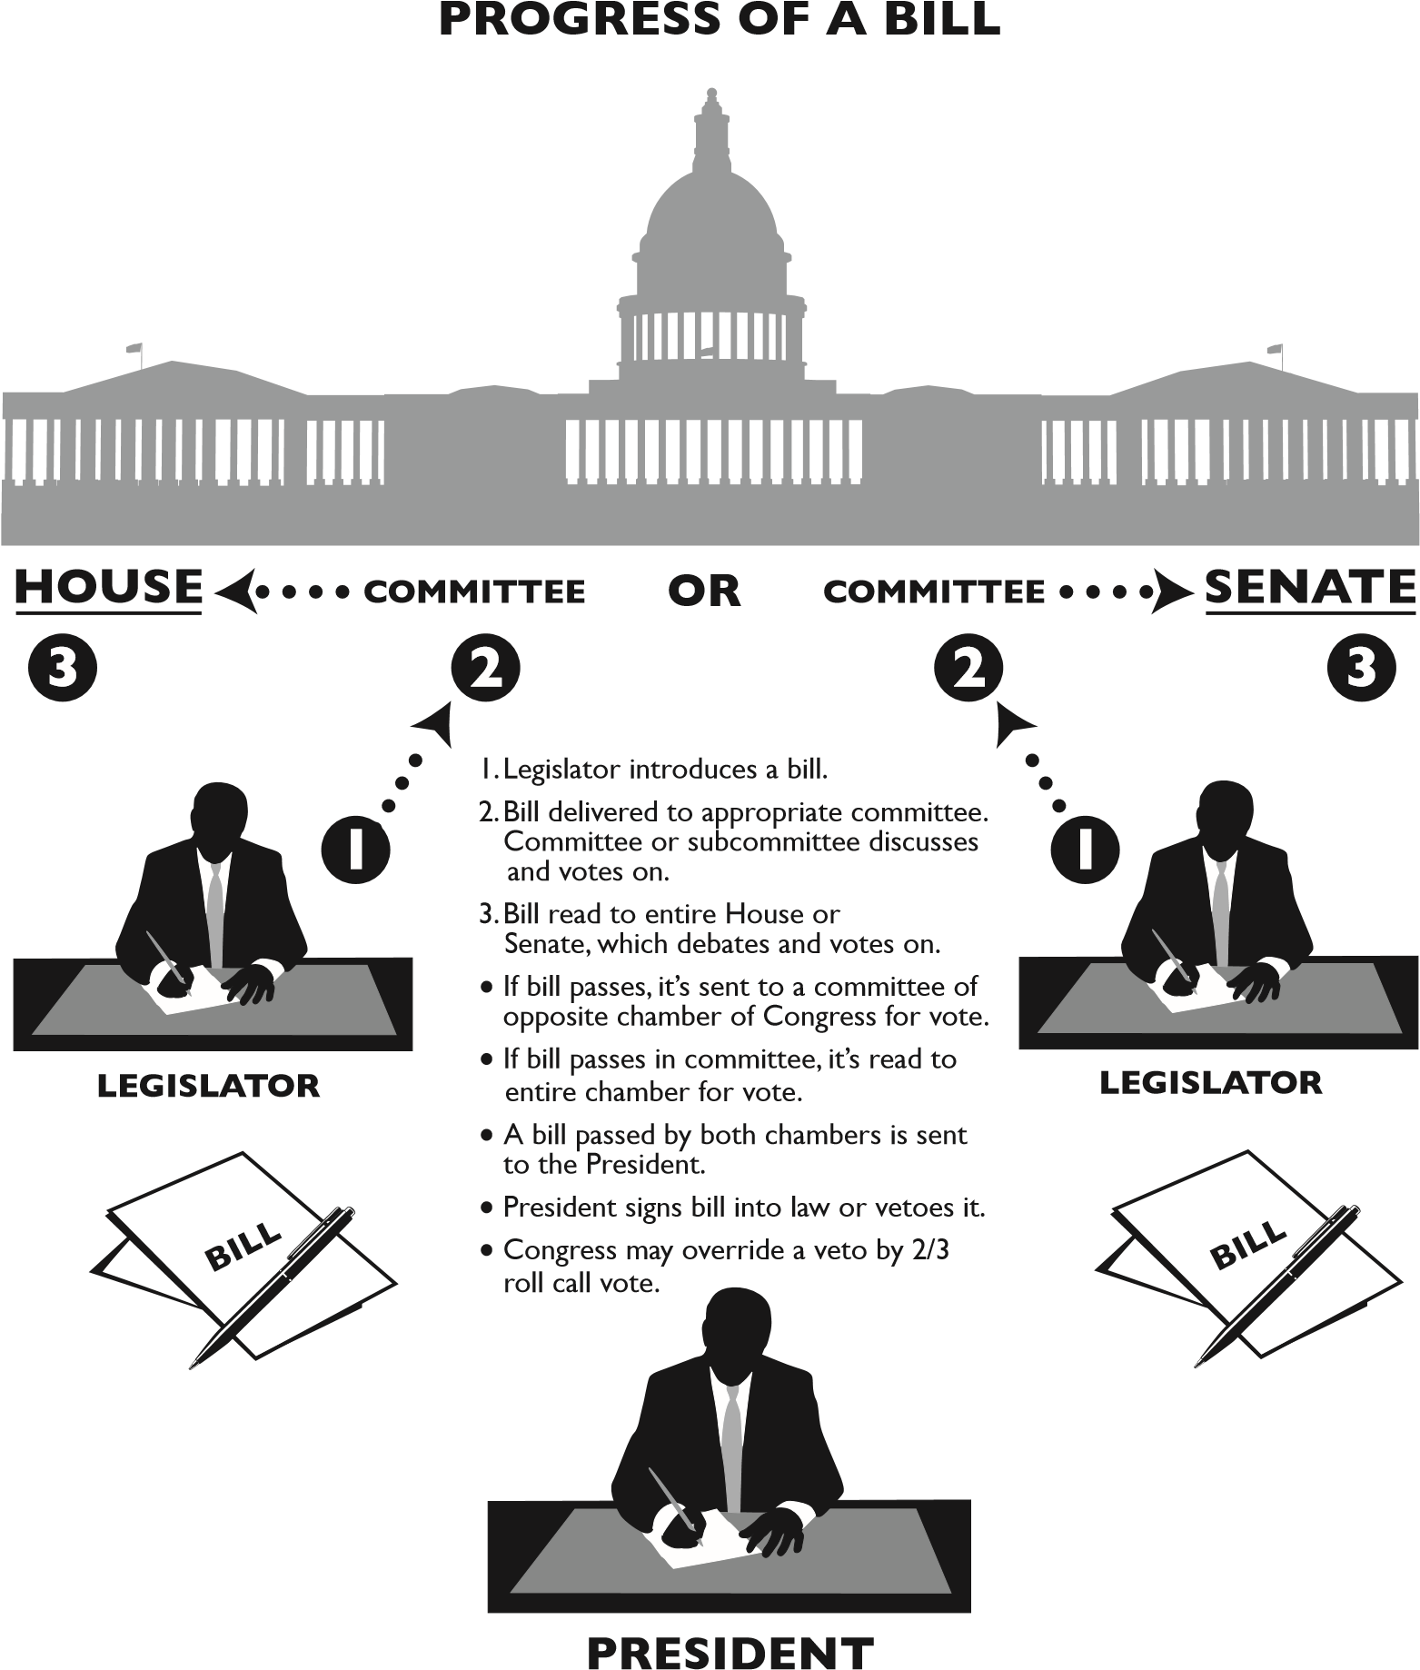
Grace Kelly-Chairperson
Grace.Kelly56@outlook.com
860-795-6442

